**Written Assignment for Paranoia**

The game we are making is a first-person horror game based in a hospital. The software we are using is unity because that is the game engine, we have the most knowledge when it comes to making the game we want to make.

**Aesthetics**

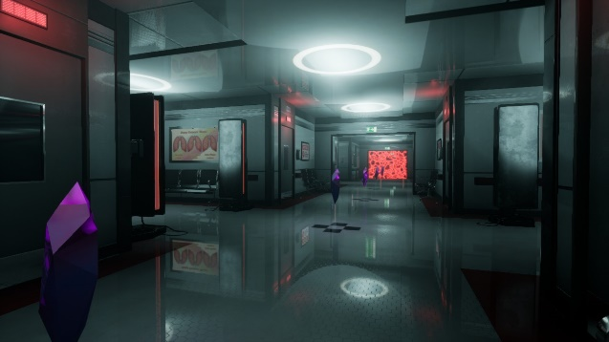

This is what we strive to the hospital at the beginning. It will be mostly isolated because the events will take place late at night and when most of the doctors will leave. Some doctors stay to look for Ben. We want the hospital to be dark throughout in order to build tension and suspense for the player. At the end, we want the player to feel immersed and isolated making Ben’s experience more impactful.

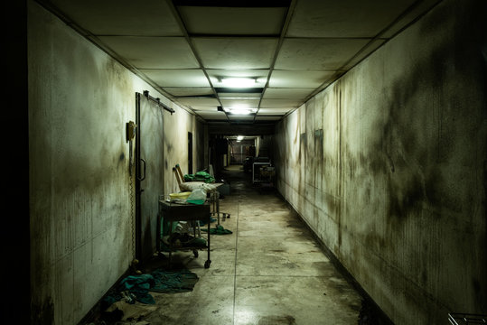

This is what we strive to the hospital to eventually get in our game, a modern hospital which eventually gets messed up. This is also what he will experience whenever he gets a mental break down. For our game is going to be a lot darker for suspense and so the players can’t see the monsters in the map.

**Floor**

There is a total no. of 6 floors in Paranoia. Here are the six areas in Paranoia starting with the area that Ben or rather the player will start in:

Basement

Main part of the hospital (ground floor)

First Floor of the hospital

Second Floor of the hospital

Secret base of the Bio Evolution Corp.

Rooftop

There are two more areas, but they will be areas in the ending of the game.

**Basement + Ground Floor**

Here is a bird’s eye view of what the Ground floor and the basement. The player starts at the basement due to the incident with Ben taking medicine that was spiked thanks to the Bio Evolution Corp. . After regaining consciousness, the player walks up the stairs to get to the ground floor. The player is then required to investigate the scene and notice that it was spiked. The player then faces an unknown creature and stabs it. After obtaining the walkie-talkie, the player than must stealthily avoid the SWAT members and reaches the main hall. There the player will investigate the registry and find an outlier, he/she will then encounter a mysterious man with glasses who will then try to kill you. After dodging, the player will go in for retaliate with the man disappearing. He leaves an electric band. The player proceeds to use the band to gain access to the first floor.

**First Floor**

Welcome to the first floor. After the player reaches the first floor, he/she can see the silhouettes of three beings. The player immediately hides behind the corner and overhears the conversation between the three monsters. The player will start exploring the cafeteria and relax as he/she gets a drink. After laying down drinking. The player will eventually notice one of the monsters looming over his/her head, in pure terror the player rolls over to the chair. The player will then start to throw the chairs to distract the monster. The player will then experience a third mental breakdown in the operation room which he gets more memories. The player will then leave to the X-Ray room which he discovers data logs by using the band to override the computers. As the player leaves, the X-Ray he gets the same monster, and the player finds the cardiac Defibrillator. The player shocks the monster until it falls unconscious. The player will then find an ID and notices he needs to get all the other IDs. The player will then explore further, discover more data logs and have more monster encounters. As the player reaches to the third monster, he/she will find out that there’s a missing biochemical. The player finds the third monster and the monster tells him the truth. Suddenly, the SWAT leader Greg shows and the third monster gets shot down to protect you. The player obtains the third ID and uses it to access the lift to the second floor.

**Second Floor**

Once the player reaches the second floor, the player reaches Ben’s room and helps to get Ben’s memory back. After interacting with a young girl, the player will get a threatening call to go to the main hall. The player reaches there only to be knocked out.

**Secret hideout**

The player regains conscious and is put in a maze segment filled with Bio Evolution Corp. members. Eventually, the player will eventually find a bomb and starts the timer. In a timer segment, the player must find his way out, eventually Greg will start chasing him. Both you and Greg barely make it with Greg pretty much singed. Eventually, Greg dies, and you get his machine gun.

**The Roof**

The player finally gets up on to the roof to meet with Jack. The atmosphere would be heavy and filled by a raging storm. After the player defeats Jack, the sun rises again to show a new beginning and hope.

**Mechanics**

We want players to explore the hospital and figure out the story for themselves, however we will add creatures/monsters, to give players a hard time discovering the hospital. The players will be given a torch and it will allow players to ward off the creatures that are after them, however there is a limited supply of batteries that the player will have meaning that have to be wise on using the torch. After every now and then, Ben is going to have to require taking these medicines, these medicines reduce the effects of his traumas. If specific events happen like if Ben was to get a mental breakdown, then the player must give Ben his medicines immediately. If he doesn’t get his medicines, his sanity levels will drop, and the screen will start to go darker. If his sanity level drop to zero, then game over.

Ben will also find key items that will be important in his discovery to the truth. Here are some of the items that the character will encounter:

**Walkie-Talkie**

He encounters a walkie-talkie after taking it from the first monster who happens to be a police officer disguised as a security officer. Unfortunately, he was viewed as a monster because Jack had spiked Ben’s Medicine. As a result, Ben gets affected by the medicine mentally and his world becomes upside-down. After experiencing his first mental breakdown, he starts to receive calls from a secret protagonist. This protagonist drops hints and lore on the protagonist Ben which in turn he uses that to find the truth. Eventually, he learns the identity of this secret protagonist who is a friend of his, Emma. Emma in turn was trying to hide the events that were happening in the hospital but eventually the other members of the force get knowledge of it and imprisons Ben for a few months.

**Electronic Band**

After dodging Jack’s attack, Ben tries to retaliate but disappears leaving an electric band. This band is an important key item if he wants to move further into the game. He can use the band to further analyse other items he will encounter in the future. He can also override computers to obtain important information. Information varies from data logs to scientific reports based on testing. Ben will eventually come to know, something sketchy is happening in the hospital and that innocent people are getting dragged in by the higher ups. With further investigation, he will find out about a missing biochemical and that someone didn’t want its presence to disappear for good.

**Long Pipe**

Although this isn’t a key item, this is a good example of an item he can find by simply exploring the hospital. Ben will find several items like this one to which he can use in various ways. He can use it as a weapon or as an item to reach to places far beyond reach. There is a moment where Ben can see one of three IDs hanging in the back of the monster. Consequently, Ben tries to stealthily use the pole to grab the ID card to which fails.

**Controls**

**Keyboard**

Main Menu

Forwards

Double Tap for sprint

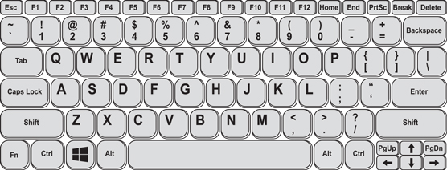

Left

Back

Hold for Sneak

Inventory

Right

Map

Walkie-Talkie

Jump

**PS4 Controller**

Main Menu

(L2) Sneak

(R2) Run

Inventory

Map



Interact

Walkie-Talkie

Jump

Camera look-around

Movement of the player

**AI Interaction - How the AI will interact?**

The creatures/Monsters that the player will face will be implemented in different ways. A good way is using environmental aspects of the game to affect events happening. For example, if the player opens the door we want the AI to be aware of that and to change it’s current status.

The creatures in the game are going to interact with the player around the hospital in various ways. This means that the AI is going to need to think and sense the environment they are in before they do an action. Essentially, we are going to give the AI appropriate code to act as a brain for the AI to do just this. For example, in the game if the creature encounters the player, the creature should start to chase the player or start to pick up objects to which it will throw at the player. However, there are going to be areas where the player can hide, allowing the game to be a little easier. Furthermore, this can include strategies for speed runners, consequently giving them more freedom to do whatever they want.

Furthermore, we will be adding AI states into the game, this is to add parameters and transitions of the characters depending on conditions. These conditions are guards and can help the AI to perform a task or change in behaviour at that specific time. A good example is when AI needs to shoot a gun at a specific distance.

public bool **GuardIdleToEngage**(State<AIStates> currentState){

return (senses.CanSeeTarget());

}

This is roughly what we will use in the code to change the state that the creature will be in.

Also, we want to introduce fuzzy logic into the code, the reason why is because Boolean logic is quite precise with the logic, however Fuzzy Logic introduces grey areas.

For example, when the player is being chased by the creature/monster in the game, the monster will have NPC navigation meaning that when it’s chasing the player it will avoid obstacles. Also, the creature will have code implemented that when the monster losses sight of the player, it will transit to walking casually assessing the environment.

The items in the game makes the states change drastically, because they’re needed to fiend away against the creature. This means that as the creature chases the player around the hospital, it would go from the Engage state to the stunned state. When the player hits the creatures enough times, the creatures would go into a stunned state before they once again regain consciousness.

We would also need to make the monsters to spawn in after specific points, e.g., seeing a data log in the orthopaedics’ office. Essentially, that gives the players some objectives to which keeps the player enjoying the game instead of going to an area whilst constantly fighting a monster. On top of that, we must consider players don’t like having to constantly be chased and attacked. Consequently, breaking immersion making it more annoying than fun.

Finally, we will be using pathfinding (A*) for the AI of the creature, meaning that the AI will use the cheapest and best route to get to the player. It’ll be like the Xenomorph from Alien Isolation or even the EMMI from Metroid Dread, essentially by AI calculating different routes the enemy’s behavioural patterns becomes unpredictable and tense. The ends up makes it more impactful when the player encounters said enemy due to the unexpected appearance overwhelming the player.

**Conclusion**

The game we are going to make is heavily incorporating AI programming, Game Design and Storytelling. So many more players can be drawn towards different aspects of the game instead of one, meaning people will have pleasure exploring the different areas the game has to offer.

**References**

* Gookin, D (2021). Laptop Keyboards.[online].Available at: <https://www.dummies.com/article/technology/computers/pcs/laptop-keyboards-283471>
* AimControllers(N/A).[online].PS4 Controller.Available at: <https://us.aimcontrollers.com/ps4-configurator/>
* motardINN.(N/A).[online]. Midland G10 Pro Walkie-Talkie.[online].Available at: <https://www.motardinn.com/motorcycle-equipment/midland-g10-pro-walkie-talkie/138242995/p>
* Ducky323(N/A).[online].The Hospital.[online].Available at: <https://dark-deception-game.fandom.com/wiki/The_Hospital>
* Freepik(N/A).[online].Abandoned alley in psychiatric hospital.Available at: <https://in.pinterest.com/pin/196399233739037614/>